Assignment -1

15 git commands with explanation and screenshots:

1. git version >> to check the current version of git
2. git init>> to initialize the repository
3. git status>> check the current status of git where its tracking
4. git add <filename> or git add . >> to update the changes made in any file or all the changes by .

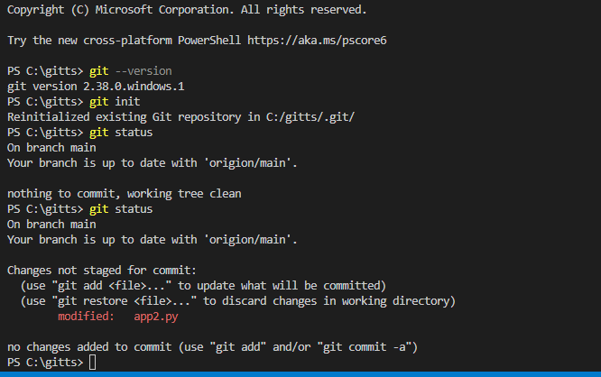

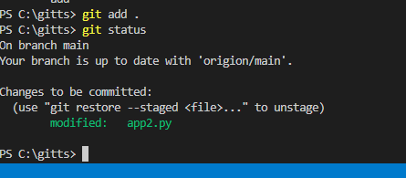

1. git commit –m “message” >> to put the changes in staging for ready state to be in pushed

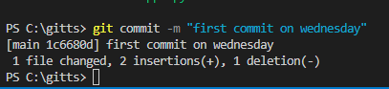

1. git remote add origion <<SSH/Https url>> to add github created origion

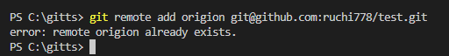

1. git remote –v >> to check the origion that is set up currently

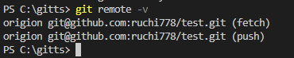

1. git branch >> to check all the branch and currently in which branch

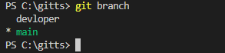

1. git branch <branch name> >> to create new branch

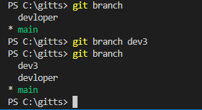

1. **git checkout <<destinated branchname >>** >> to move in other branch

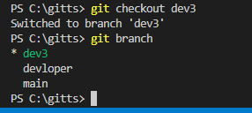

1. git push origion main >> to push all the staging changes in destinated branch eg main

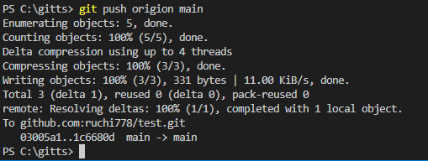

1. git branch –d <<branch name>> >> deleting the branch



1. git config --global user.email [ruchii22yadav22@gmail.com](mailto:ruchii22yadav22@gmail.com) >> to setthe github user email



1. git config –globaluser.name “Ruchi” >> to set the github user name



1. git merge <branchname> to merge the branch with the current branch changes

